Golf should be fun!
You should feel safe and enjoy your sport
Is something worrying you? Need someone to talk to?
Speak to your Club Welfare Officer
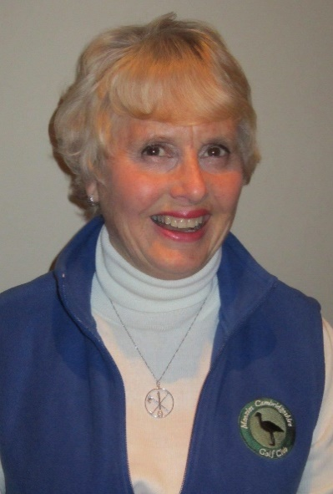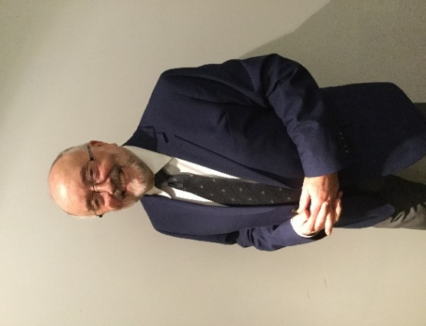
ROSEMARY RENNIE PETER HYNES
Email address: Email address:
rosemary.rennie@ntlworld.com peter.hynes156@gmail.com
Telephone Number: Telephone Number
01480 350084 07505 354767

Alternatively, you can speak to someone at:
ChildLine 0800 1111 | NSPCC 0808 800 5000 | England Golf 01526 351851

